Loss (MNIST-resnet50) 0.0121, 0.0701

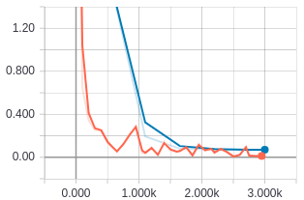

Test accuracy (MNIST-resnet50) 97.76

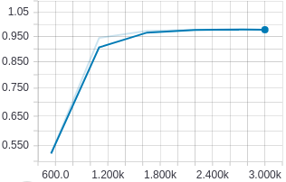

Train accuracy (MNIST-resnet50) 99.7

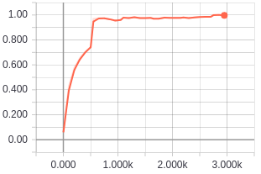

Loss (MNIST-resnet101) 0.0353, 0.0698

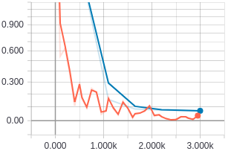

Test accuracy (MNIST-resnet101) 97.98

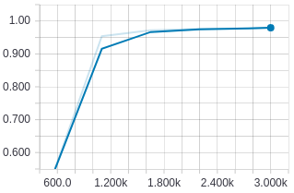

Train accuracy (MNIST-resnet101) 99.67

